Machine Learning Course Workbook
– Day 1 –

The Basics

What is ML?

What is the difference between Machine Learning, Artificial Intelligence, and Deep Learning?

What are the benefits of ML compared to traditional software?

When should you not use ML?

Which kind of ML problems have a high chance of success and when is the outcome uncertain?

How do machines “learn”?

Describe the different learning strategies and what their requirements (in terms of data) are:
- Unsupervised Learning:
- Supervised Learning:
- Reinforcement Learning:

What are “features” and what are “labels”?
- Features:
- Labels:

What is the goal of a supervised learning algorithm and how is it accomplished?

ML use cases

What does structured and unstructured data look like? Which of them is homogeneous and which (usually) heterogeneous?
- Structured Data:
- Unstructured Data:

Take another look at the ML algorithm cheat sheet & try to find examples where you could be using each of these algorithms to improve your organization’s products or processes.
- Anomaly Detection:
- Clustering:
- Regression:
- Classification:

What is the drawback of unsupervised learning methods?

What are the benefits of breaking down a complex input-output problem into simpler subproblems?

What is the downside of a system composed of multiple ML models?

Solving problems with ML

What are the two deployment options for an ML model and when should you use which?

ML with Python

What are the standard abbreviations used when importing the numpy and pandas libraries?
import numpy as ...
import pandas as ...

– Day 2 (Part 1) –

Data Analysis & Preprocessing

Data Analysis

What does Goodhart’s Law warn us about?

With what KPI could your department’s goal be quantified? Is this a leading or lagging KPI?

Garbage in, garbage out!

Think about some of the datasets you’ve encountered in the past: In what ways were they messy?

Which concrete next steps should your organization take to improve their data quality?

Data Preprocessing

What is the difference between feature extraction and feature engineering?
- Feature Extraction:
- Feature Engineering:

A feature matrix X has the shape (n x d). What do n and d stand for?
- n: number of ...
- d:

You are given a dataset with time series data, consisting of measurements from d sensors for n time points. What would your feature matrix look like, if your task was…
- … to make a prediction for each time point?
- … to categorize the different sensors?
- … to predict the quality of each of the 100 products produced during this time span?

What is one way to transform categorical features into a meaningful numerical representation?

These are the histograms of three different variables A, B, and C:
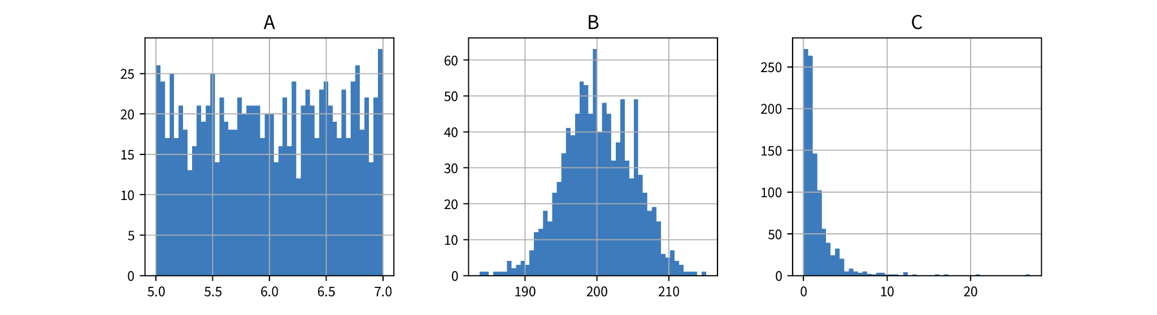
How would you characterize their distributions (Gaussian, exponential, uniform) and which kind of transformation (StandardScaler, MinMaxScaler, PowerTransformer) might be best suited for which of the variables?
- A:
- B:
- C:

What preprocessing steps can be helpful to compute a more meaningful similarity or distance between the data points’ feature vectors (especially for heterogeneous data)?

Supervised Learning Basics

Different types of models

What is the difference between a regression and a classification problem?

When should you use a features-based and when a similarity-based model and what are their respective drawbacks?

Model Evaluation

With which stupid baseline should you compare regression and classification models respectively?

When is it a really bad idea to evaluate a classification model with the accuracy metric?

How does a cross-validation work? What are the advantages and disadvantages compared to using a fixed validation set?

– Day 2 (Part 2) –

Supervised Learning Models

Linear Models

How does a linear model compute the prediction for a new data point?

What happens when you use a regularized model and set the regularization parameter to a high value (e.g., alpha for a linear ridge regression model in sklearn)?

Neural Networks

How does a feed forward neural network (FFNN) compute the prediction for a new data point?

How could a multi-layer FFNN be simplified, if it did not contain any nonlinear activation functions between its layers?

In what way could you manipulate the parameters (i.e., weight matrices) of an existing FFNN without changing its predictions?

Decision Trees

How does a decision tree compute the prediction for a new data point?

For a decision tree with max_depth=2, how many different features can be used at most for the prediction?

Ensemble Methods

What are the different strategies for creating ensemble models?

How does a random forest compute the prediction for a new data point?

k-Nearest Neighbors (kNN)

How does a kNN model compute the prediction for a new data point?

Why is it better to use an odd number of nearest neighbors for kNN for a binary classification problem?

Kernel Methods

How does a kernel ridge regression (KRR) model compute the prediction for a new data point?

Why is it more efficient to compute the prediction for a new data point using a support vector machine (SVM) model compared to KRR?

– Day 3 –

Avoiding Common Pitfalls

Model does not generalize

How can you tell whether a model underfits the data and what can you do to improve the model’s performance if this is the case?

How can you tell whether a model overfits the data and what can you do to improve the model’s performance if this is the case?

Why can the performance on the training set get worse as the size of the training set increases?

Why should you not use a univariate feature selection approach? What are better alternatives?

Model abuses spurious correlations

Why can a model still be wrong, even though it generates correct predictions for data points from the testset?

What are “Adversarial Attacks”?

Model discriminates

Why can it happen that a model discriminates and in what ways could this negatively affect users?

How can you check whether a model discriminates?

Explainability & Interpretable ML

What is the difference between local and global explainability?

How can you explain an individual prediction of …
- a decision tree?

a linear model?
- a neural network?

How can you identify the features that are overall the most important for a model?

How can you determine (approximately) how an individual feature influences the model prediction overall?

What model-agnostic approach can you use to explain an individual prediction of any model?

Data & concept drifts

What is the difference between data and concept drift?

What could be reasons for data or concept drift in your domain / next project?

