Machine Learning Course Workbook
– Before the Course –

Introduction

ML is everywhere!

Where (else) do you use ML in your everyday life incl. work?

ML history: Why now?

What accelerated the rise of ML in the last few years?

What is the difference between ANI and AGI?

– Part 1 –

The Basics

What is ML?

What is the difference between Machine Learning, Artificial Intelligence, and Deep Learning?

What are the benefits of ML compared to traditional software?

When should you not use ML?

Which kind of ML problems have a high chance of success and when is the outcome uncertain?

How do machines “learn”?

Describe the different learning strategies and what their requirements (in terms of data) are:
- Unsupervised Learning:
- Supervised Learning:
- Reinforcement Learning:

What are “features” and what are “labels”?
- Features:
- Labels:

What is the goal of a supervised learning algorithm and how is it accomplished?

ML use cases

What does structured and unstructured data look like? Which of them is homogeneous and which (usually) heterogeneous?
- Structured Data:
- Unstructured Data:

Take another look at the ML algorithm cheat sheet & try to find examples where you could be using each of these algorithms to improve your organization’s products or processes.
- Dimensionality Reduction:
- Anomaly Detection:
- Clustering:
- Regression:
- Classification:
- Deep Learning:
- Recommender Systems/Information Retrieval:
- Reinforcement Learning:

What is the drawback of unsupervised learning methods?

What are the benefits of breaking down a complex input-output problem into simpler subproblems?

What is the downside of a system composed of multiple ML models?

Solving problems with ML

What are the two deployment options for an ML model and when should you use which?

ML with Python

What are the standard abbreviations used when importing the numpy and pandas libraries?
import numpy as ...
import pandas as ...

Data Analysis & Preprocessing

Data Analysis

What does Goodhart’s Law warn us about?

With what KPI could your department’s goal be quantified? Is this a leading or lagging KPI?

Garbage in, garbage out!

Think about some of the datasets you’ve encountered in the past: In what ways were they messy?

Which concrete next steps should your organization take to improve their data quality?

Data Preprocessing

What is the difference between feature extraction and feature engineering?
- Feature Extraction:
- Feature Engineering:

A feature matrix X has the shape (n x d). What do n and d stand for?
- n: number of ...
- d:

You are given a dataset with time series data, consisting of measurements from d sensors for n time points. What would your feature matrix look like, if your task was…
- … to make a prediction for each time point?
- … to categorize the different sensors?
- … to predict the quality of each of the 100 products produced during this time span?

What is one way to transform categorical features into a meaningful numerical representation?

These are the histograms of three different variables A, B, and C:
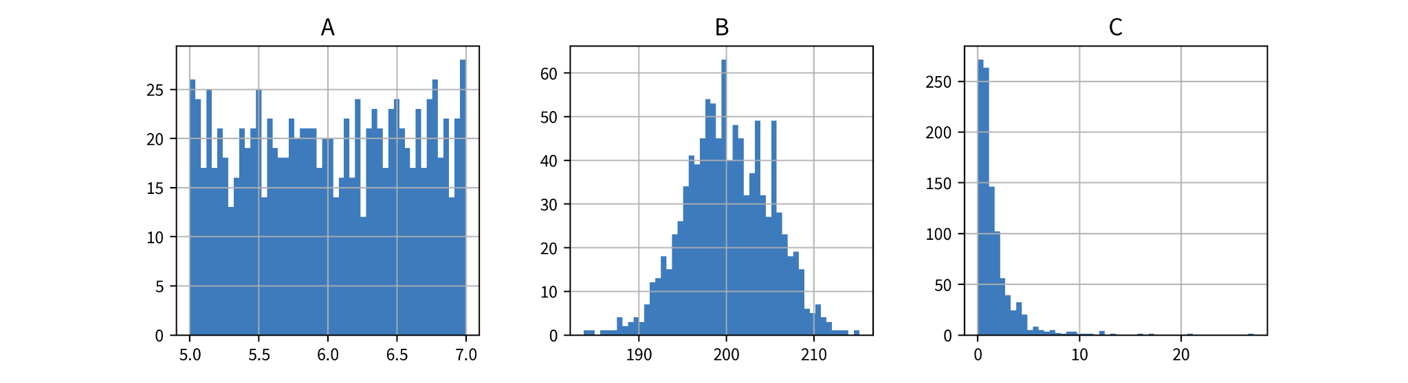
How would you characterize their distributions (Gaussian, exponential, uniform) and which kind of transformation (StandardScaler, MinMaxScaler, PowerTransformer) might be best suited for which of the variables?
- A:
- B:
- C:

What preprocessing steps can be helpful to compute a more meaningful similarity or distance between the data points’ feature vectors (especially for heterogeneous data)?

What are the steps to transform a corpus (i.e., dataset with text documents) into a TF-IDF feature matrix?

What are the disadvantages of TF-IDF feature vectors?

– Part 2 –

Unsupervised Learning

Dimensionality Reduction

Guess: Which plot was generated with PCA and which with t-SNE?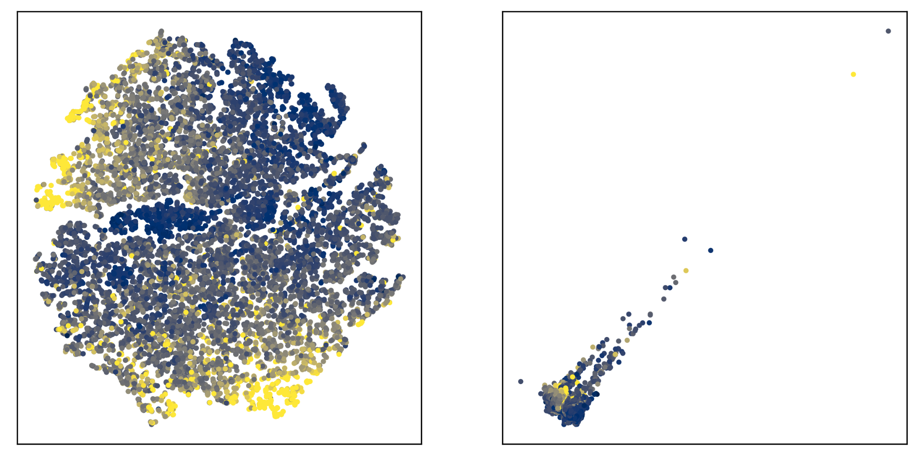

How does PCA work?

Is PCA using the original input features for the computation or does it first compute a similarity matrix for the data points? What about Kernel PCA?

How does t-SNE work?

Is t-SNE using the original input features for the computation or does it first compute a similarity matrix for the data points?

When would you use PCA and when would you use t-SNE?

In the notebook, what did you observe about the PCA eigenvalue spectrum for the data with and without outliers? How do you interpret this?

Outlier/Anomaly Detection

What factors should you consider when choosing an outlier detection method?

Why can a data point still be an outlier even if it is within normal ranges of the individual features?

How does the 𝛾-index work and how could you set the parameter k if you suspect clusters of outliers?

Clustering

How does the k-means algorithm work?

True or False: One disadvantage of k-means is that it assumes spherical clusters?

How does the DBSCAN algorithm work?

What are the advantages of DBSCAN?

Supervised Learning Basics

Different types of models

What is the difference between a regression and a classification problem?

How can you tell if a classification or regression dataset is linear or nonlinear (e.g., with one input x)?

When should you use a features-based and when a similarity-based model and what are their respective drawbacks?

Model Evaluation

With which stupid baseline should you compare regression and classification models respectively?

Name three regression evaluation metrics:

Name two classification evaluation metrics:

When is it a really bad idea to evaluate a classification model with the accuracy metric?

How does a cross-validation work? What are the advantages and disadvantages compared to using a fixed validation set?

– Part 3 –

Supervised Learning Models

Linear Models

How does a linear model compute the prediction for a new data point?

What happens when you use a regularized model and set the regularization parameter to a high value (e.g., alpha for a linear ridge regression model in sklearn)?

Neural Networks

How does a feed forward neural network (FFNN) compute the prediction for a new data point?

How could a multi-layer FFNN be simplified, if it did not contain any nonlinear activation functions between its layers?

In what way could you manipulate the parameters (i.e., weight matrices) of an existing FFNN without changing its predictions?

Decision Trees

How does a decision tree compute the prediction for a new data point?

For a decision tree with max_depth=2, how many different features can be used at most for the prediction?

Ensemble Methods

What are the different strategies for creating ensemble models?

How does a random forest compute the prediction for a new data point?

k-Nearest Neighbors (kNN)

How does a kNN model compute the prediction for a new data point?

Why is it better to use an odd number of nearest neighbors for kNN for a binary classification problem?

Kernel Methods

How does a kernel ridge regression (KRR) model compute the prediction for a new data point?

Why is it more efficient to compute the prediction for a new data point using a support vector machine (SVM) model compared to KRR?

Avoiding Common Pitfalls

Model does not generalize

How can you tell whether a model underfits the data and what can you do to improve the model’s performance if this is the case?

How can you tell whether a model overfits the data and what can you do to improve the model’s performance if this is the case?

Why can the performance on the training set get worse as the size of the training set increases?

Why should you not use a univariate feature selection approach? What are better alternatives?

Why can it hurt the performance if you (aggressively) reduce the dimensionality of the data with PCA?

Model abuses spurious correlations

Why can a model still be wrong, even though it generates correct predictions for data points from the testset?

What are “Adversarial Attacks”?

Model discriminates

Why can it happen that a model discriminates and in what ways could this negatively affect users?

How can you check whether a model discriminates?

What can you do to get a fair model?

Explainability & Interpretable ML

What is the difference between local and global explainability?

How can you explain an individual prediction of …
- a decision tree?

a linear model?
- a neural network?

How can you identify the features that are overall the most important for a model?

How can you determine (approximately) how an individual feature influences the model prediction overall?

What model-agnostic approach can you use to explain an individual prediction of any model?

Data & concept drifts

What is the difference between data and concept drift?

What could be reasons for data or concept drift in your domain / next project?

– Part 4 –

Advanced Topics

Deep Learning

What type of neural network architecture would be a natural choice for sequential data like text or time series data? What about image data?

How does self-supervised learning work (e.g., using text data)?

How does transfer learning work and when can it help?

Information Retrieval (Similarity Search)

What is the most important (and difficult) step when trying to solve an information retrieval task?

Recommender Systems (Pairwise Data)

What kind of problems (in terms of inputs and outputs) can you solve with recommender systems?

What is the “cold start problem” and how can you circumvent it?

Time Series Forecasting

What kind of input features could you use to forecast how many pretzels a bakery will sell tomorrow?

What is the difference between stateless and stateful models and which conditions need to be fulfilled so it makes sense to use a stateless time series forecasting model?

Reinforcement Learning

For which kinds of tasks does it make sense to use reinforcement learning and when does a normal optimization suffice?

How does the Epsilon-Greedy Policy manage the trade-off between exploration and exploitation?

What is a Q-value and how does Q-learning for tabular RL work?

How can Q-learning be extended to work with an infinite number of states?

Which factors can complicate the use of reinforcement learning?

– Part 5 –

Conclusion

What can you do if you have “big data”?

AI Transformation of a Company

According to Andrew Ng, what are the 5 steps for a successful AI transformation of a company and where do you think your organization stands in this process?

